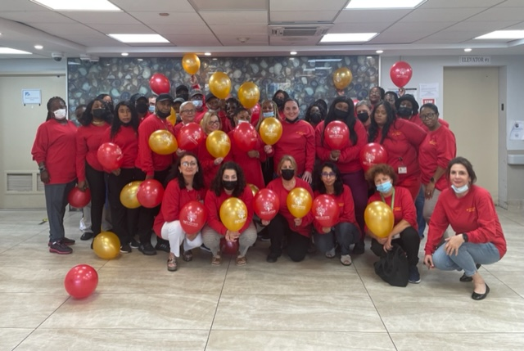
Oceanview Manor Home for Adults Celebrates Assisted Living Week 2022
National Assisted Living Week® (NALW) is an annual event that was established in 1995 by the National Center for Assisted Living (NCAL). This event, which starts on Grandparent’s Day, provides residents, their loved ones, and staff members of assisted living communities across America a unique opportunity to celebrate what assisted living means for seniors and those with disabilities.
This year the week started on September 11th and goes through the 17th. The main goal of this special week is to educate members of the public about assisted living and long-term care as well as celebrate those who serve in the assisted living communities.
This year’s theme “Joyful Moments” honors the families, residents, assisted living staff, and the assisted living communities and allows them to come together and make memorable times and joyful memories together with both the big and small moments in life
“We have seen and been through a lot during the previous two years with the pandemic. Our dedicated team has been steadfast in providing the best possible care and support to all of our residents and most importantly each other. We need to celebrate this type of teamwork and dedication. Assisted Living Week was the perfect time to renew our joy for the care and services that we provide.” Says Lisa Vider, Administrator of Oceanview Manor. “We are proud of our Home and I am proud of our team.”
We at Oceanview Manor Home look forward to another year of “Joyful Moments” with our team members, Medical Team, Nursing staff, Families, Surrounding Community and most of all our residents
Happy National Assisted Living .Week to all.

